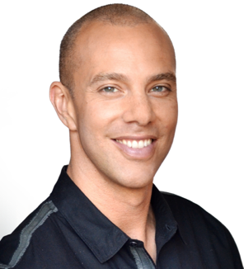

**Volume 1 Issue 1 January 2021**

**Doren Aldana’s**

**Home Newsletter**



These boxes throughout the document will contain TIPS to make your newsletter sell. Be sure to DELETE THESE BOXES BEFORE PRINTING AND MAILING.

These boxes throughout the document will contain TIPS to make your newsletter sell. Be sure to DELETE THESE BOXES BEFORE PRINTING AND MAILING.

Volume, Issue

December 2005

These boxes throughout the document will contain TIPS to make your newsletter sell. Be

Volume, Issue

Month, Year

***Adding Value to Your Life with News, Tips and Entertainment***

Home Closing Checklist: 6 things to do before you move in.

**DorenAldana**

**Mortgage Advisor**

ABC Mortgage

Phone: 604-990-4303

Fax: 604-990-4305

doren@abcmortgage.com



You’ve found the perfect home and your offer has been accepted. Congratulations! Now all you have to do is make sure the deal closes smoothly and on time. To help ensure success, here’s a checklist of 6 things to do before you close…

1. **Remove conditions.** These items need to be completed to your satisfaction before the deal closes. For instance, if the home inspection uncovers a problem, the seller needs to fix it or you can back out of the

Inside This Issue…

Home Closing Checklist: 6 Things To Do Before You   
Move In ……………….…….....1

Client News ............................ 2

How To Buy A House That’s Not On The Market ..………..……..2

How To Stay Warm This Winter Without Spending A Fortune   
On Heating……..…………...... 3

5 Ways To Protect Yourself When Someone In Your Home Gets COVID …..….…………... 3

Quiz of the Month ................... 4

Ultimate Home Buyer   
Success Kit ......................….. 4

deal. Similarly, if the lender’s appraisal is less than the sale price, an appraisal condition lets you back out. And a financing condition releases you from the deal if you don’t get mortgage approval.

1. **Make sure the title is clear.** Your lender will require a title search to confirm that the seller is the legal owner. Get your lawyer to examine the title, or purchase title insurance to protect against any future claims to the property.
2. **Get final mortgage approval.** Chances are you were pre-approved before you made the offer. Now the lender has to do an up-to-the-minute check of your finances in deeper detail before giving final approval.
3. **Review your mortgage details.** Confirm that the payments and terms are what you were promised. Make sure you have enough funds to cover all closing costs and property tax adjustments.
4. **Do a pre-closing walk-through.** Your Realtor should have added a clause to the Offer to Purchase so you can visit the home a day or two before closing to make sure it’s in the condition you expect, including any agreed-upon repairs.
5. **Have all documentation ready for the closing meeting.** When you sit down with the lawyer to sign the final documents, you’ll need to show proof of homeowner’s insurance, the sales contract, home inspection report, mortgage documents, and government-issued photo ID. Then you get the keys and the house is yours!

If you’d like assistance with the closing process, we’re here to help. Call us today!

**Quote of the Month**

### *"The learner always begins by finding fault, but the scholar sees the positive merit in everything.”*

### *-* Georg Wilhelm Friedrich Hegel

Client News

**DELETE THIS AFTER READING!**

How about welcoming your new clients to the firm, and giving recognition to the clients that referred them in? This is a great way to stimulate more referrals! (Of course, you must get their permission before doing this!)

Here are the new clients who became members of our firm’s family in the last month! We’d like to welcome you publicly, and send you our best wishes!

**Bob and Karen Schwartz from Middletown (Referred in by Sarah Parker! Thanks!)**

Larry Primrose from Trenton

**Sue and Linda Winthrop from Middletown (Referred in by Kelly Winthrop! Thanks!)**

Carl and June Lockhart from Bainbridge (Referred in by Sam and Brea Weir! Thanks!)

**Joyce Smith and Jim Aito from Trenton**

Janet Collins from Bainbridge (Referred in by Sarah Parker! Thanks again!

**Gerry and Jenny Bozman from Middletown. (Referred in by Sarah Parker! Thanks!)**

*We love giving recognition to our new friends and our wonderful existing clients who are kind enough to refer their friends and relatives to us! We’re all helping each other, which is the whole point of all this! Right?*

zz





Seasonal Article of the Month

How to buy a house that's not on the market.



In a competitive real estate market, it may be difficult to find the house you’re looking for. And when you finally find it, you could be outbid by another buyer. That’s why many buyers are looking for homes BEFORE they’re listed.

Here’s how your Realtor can help you find an unlisted home:

* Contact expired listings. If the sellers were unsuccessful in the past, they may be open to selling now.
* Check ownership records to see which homes are vacant or investment properties.
* Mail postcards to desirable neighborhoods that say a qualified buyer is interested in buying if homeowners are interested in selling.

Here are some things you can do yourself before getting a Realtor involved:

* Get pre-approved for financing so you’re ready to buy as soon as the right house comes along.
* Be clear on the maximum offer you can make, taking into consideration closing fees, moving, renovations, etc.
* Keep your schedule flexible so you can look at available homes at a moment’s notice.
* Tour desirable neighborhoods and write down specific addresses you’re interested in. These can be given to your Realtor, or you can just knock on doors.
* Be ready to go in with your best offer first. After all, you have to motivate the buyer to sell.

If you’d like more advice on buying a house that’s not on the market, call us today!

Financial Freedom Tip of the Month

How to stay warm this winter without spending a fortune on heating.

Home heating costs seem to rise every year, and this winter may be even more costly if you’re spending more time at home during the pandemic. But there are ways to reduce heating costs without shivering until spring. Here are some suggestions:

* **Seal around windows and doors.** Gaps let cold air in and warm air out. Use weather stripping and caulking to stop air leaks. Save even more by installing energy-efficient windows and doors.
* **Capture the sun’s heat.** Keep curtains open on south-facing windows during the day. Close curtains on north-facing windows and during the night.

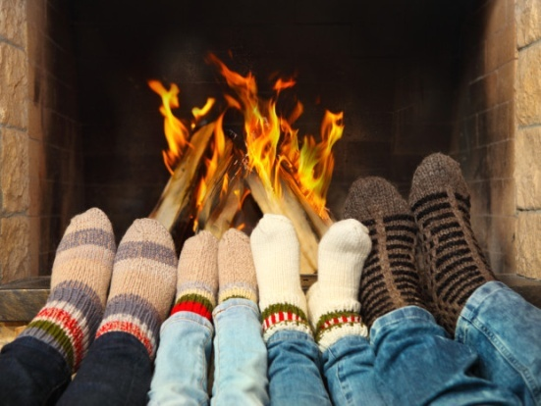

* **Tune up your furnace.** Every fall, get a professional to clean, lubricate and adjust your furnace. This increases efficiency and reduces cost.
* **Replace or clean your furnace filter.** A dirty filter restricts airflow so your furnace works harder—and consumes more energy. Replace or clean your filter every fall.
* **Consider multi-zone heating.** This requires an investment, but it will pay for itself in energy savings by letting you heat only the rooms you use.
* **Turn down the temperature while you’re out or sleeping.** This creates immediate savings. And you can make it super easy by installing an automatic thermostat.
* **Set the temperature a little lower and dress a little warmer.** Wear wooly socks, have cozy blankets on the couch, and put an extra thick quilt on your bed.

Holistic Health Tip of the Month

5 ways to protect yourself when someone in your home gets COVID.

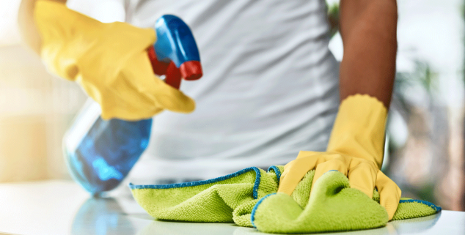

Just because someone you live with tests positive for COVID-19 doesn’t mean you’re going to get it too. Here are some ways to protect yourself:

1. **Limit contact.** Stay 2 metres apart. Use a separate bedroom and bathroom if possible. Keep all interactions brief. The farther away you are and the briefer the contact, the less likely you are to acquire a large viral load. If you get infected, the smaller the viral load, the less sick you’ll be.
2. **Wear a mask.** Both you and the person with COVID should wear a mask whenever you’re less than 2 metres apart. If you also wear goggles, you’ll prevent the virus from entering your body through your eyes.
3. **Wash and disinfect regularly.** Both of you should wash your hands with soap and water regularly, especially after contact. Use disinfectant to clean tables, toilets, faucets, door handles, light switches, phones, etc.
4. **Keep windows open.** This is useful even if it means turning up the heat. The better the ventilation, the less virus will be in the air.
5. **Get your information from reliable sources.** Don’t rely on what you hear about COVID from friends, family and social media. Much of this information can be incorrect or even dangerous. If you’re unsure of something, talk to your primary care doctor or visit the Public Health Agency of Canada’s website.

Quiz Question of the Month

**Answer to Last Month's Quiz**

Poinsettias add color to Christmas celebrations. Aside from red, what other colors do poinsettias come in?

1. Pink
2. Light Green
3. White
4. Yellow
5. All of the above

ANSWER: e) All of the above

January Trivia Question

Which member of the British royal family was born in January?

1. Prince Harry
2. Duchess of Cambridge (Kate Middleton)
3. Duchess of Cornwall (Camilla Parker Bowles)
4. Prince Philip

**ANNOUNCING LAST MONTH’S WINNERS!**

Congratulations to Sarah and Dan Penner of North Vancouver for winning last month’s quiz contest! They have won a FREE dinner for themselves and another couple at the Salmon House in West Vancouver. Enjoy!

**How does this contest work?**

The first person to respond with the correct answer will win a FREE Dinner for themselves and another guest couple of their choice!

**How do I submit my answer?**

To respond with your answer, email us: email@yourweb.com or fax (xxx-xxxx) in your answer with the enclosed “Free Info” request form. The contest deadline is MM/YY.

**DELETE THIS AFTER READING!**

You can get access to this report at: <https://bit.ly/2Da981T>

Resource of the Month

**HOME BUYER WARNING:** Don’t make any offers until you protect yourself with this important information.



Buying a home is a major investment no matter how you look at it. But for many home buyers it’s a lot more expensive than it should be because they fall prey to common and costly mistakes, which results in them either paying too much for the home they want, or losing their dream home altogether. Unfortunate but true.

As your mortgage advisor, I’ve prepared an informative home buyer resource entitled, ***“The Ultimate Home Buyer Success Kit"*** *--*an absolute must for any prudent home buyer. Here’s just a portion of what you’ll get in your kit:

* Free Guide: *15 Home Buyer Mistakes and How to Avoid Them*
* *How to Find Your Dream Home* Checklist
* $200 Closing Costs Coupon
* Rolodex of Our First Class Service Providers for All Your Home Buying Needs and much, much more!

To request your free copy of our Ultimate Home Buyer Success Kit, call our 24hr info hotline today at: 1-800-123-1234 Ext. 235.

As you can see, we’ve got a growing selection of free reports that are jam-packed with valuable tips and proven strategies to help you and your friends and family avoid costly financial pitfalls. If you’d like us to rush you one or more of these free reports, please fill out the reply form below and submit it by fax: 1-800-XXX-XXXX or snail mail it to: 123 any street, any town, any province, postal code.

Have you gained value from this newsletter? If so, we want to invite you to “pay it forward” by giving the **GIFT of a FREE SUBSCRIPTION** to your friends, co-workers, relatives, business acquaintances, etc. Simply fill out the info on the “Subscribe-a-Friend” form at the bottom of this page, and we’ll send them a free subscription. As a courtesy to you, we’ll also enclose a special note along with their first issue telling them that you asked us to surprise them with this free gift. And of course, they can contact us any time if they’d like to cancel. If you’ve been enjoying our newsletter, this is your hassle-free opportunity to share it with the people you care about - for FREE!

**“Do You Have All the Information You Need To Make An Informed Decision About Buying, Selling, or Refinancing Your Home?”**

###### YES! Please send the FREE Report(s) I’ve selected below: To Get Your Free Copy of Any Of These Reports Simply Call our 24hr Hotline 1-800-XXX-XXXXor Check Off The Ones You Want On This Form And Mail/Fax It In!

**Press Extension:**

[ ] “15 Home Buyer Mistakes and How to Avoid Them” - Ext. 1304

[ ] “27 Home Seller Mistakes and How to Avoid Them” - Ext. 1305

[ ] “12 Simple No-Cost Ways to Repair Your Credit” - Ext. 1306

**YES! I’d like your trusted advice and counsel about:**_____ Getting a Mortgage _____ Refinancing _____ Other

**Your Contact Information:**

First Name ____________________________ Last Name _______________________________ Best time to contact _______________

Address _______________________________________________________________________________________________________

Town _____________________________________________ Province _________________ Postal Code _______________________

Phone _____________________________ Fax _______________________ Email___________________________________________

**Don’t forget to send in your Client Quiz answer to win a FREE DINNER! Submit your answer by fax, mail or email.**

Also, please contact me to help me with: _____ Getting a Mortgage _____ Refinancing

**Don’t forget to send in your Client Quiz answers to win a FREE DINNER!**

**My answer for the Client Quiz of the Month is:** ________________________________________________

Also, please contact me to help me with: _____ Getting a Mortgage _____ Refinancing

**Don’t forget to send in your Client Quiz answers to win a FREE DINNER!**

**My answer for the Client Quiz of the Month is:** ________________________________________________

### “Free Info” Request Form

**Answers To Last Month's Quiz**

Q. According to the Census Bureau, which of the following categories did Americans spend the most on in 2004?

1. Sporting Goods 2. Jewelry

3. Shoes 4. Pets

A. The correct answer is: Pets - According to the U.S. Census Bureau, Americans spent $34.3B on their pets in 2004, up from $17B in 1994. An estimated 63% of households own a pet and 45% of households own more than one pet. The most popular remains man's best friend, the dog, with 43.5M households claiming a canine relative. In fact, the average dog owner spent $1,571 per animal last year. In second place is the cat which 37.7M homes claimed as a pet. The most populous pet turns out to be the freshwater fish. The American Pet Products Manufacturers Association estimates that there are 139M freshwater fish kept as pets in 14M households.

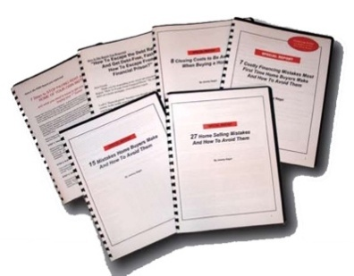

**Answers To Last Month's Quiz**

Q. According to the Census Bureau, which of the following categories did Americans spend the most on in 2004?

1. Sporting Goods 2. Jewelry

3. Shoes 4. Pets

A. The correct answer is: Pets - According to the U.S. Census Bureau, Americans spent $34.3B on their pets in 2004, up from $17B in 1994. An estimated 63% of households own a pet and 45% of households own more than one pet. The most popular remains man's best friend, the dog, with 43.5M households claiming a canine relative. In fact, the average dog owner spent $1,571 per animal last year. In second place is the cat which 37.7M homes claimed as a pet. The most populous pet turns out to be the freshwater fish. The American Pet Products Manufacturers Association estimates that there are 139M freshwater fish kept as pets in 14M households.

**Subscribe-A-Friend Request Form**

**[ ] YES! Please give the following people a FREE subscription to your monthly newsletter. I understand you’ll enclose a special note informing them that I asked you to surprise them with this free gift, and that all they have to do is contact you if they wish to cancel.**

Full Name _____________________________________________ Address ____________________________________________  
Town _______________________________________________ Province ________________ Postal Code___________________

Fu Full Name _____________________________________________ Address ____________________________________________  
Town _______________________________________________ Province ________________ Postal Code___________________

Please use the back of this form if you need more room. Remember to submit your Quiz answers to win a FREE dinner!



BEFORE YOU SEND OUT YOUR NEWSLETTER YOU MUST READ THESE IMPORTANT INSTRUCTIONS!

Dear Done4U Newsletter Member,

I want to make sure you understand how to get the most value from your Done4U client newsletter so you can build Top of Mind Consciousness with your prospects, clients and referral sources and maximize your referrals and repeat business.

Here are the critical steps you must take to ensure success with your newsletter:

**STEP #1:** Watch the orientation video to learn how to customize your newsletter. Just go to: <http://budurl.com/customizeletter> (personalize all text in red then turn it back to black).If this is not your FIRST issue, be sure to add in the answers to last month’s quiz and announce the winners.

Things to customize:

* Header
* Name of Newsletter
* Pic and Contact info (page 1)
* Client News
* Quiz of the Month: a) How to respond b) Last month’s winners
* Resource of the Month: Contact Info
* Free Info Request Form
* Cover Letter (If Applicable)
* Contest Insert (If Applicable)

**STEP #2:** If there are any articles included in this month’s issue that you don’t want to include, you can easily replace it with another article found in our article archive here: <https://b.link/articlearchive>

**STEP #3:** Get access to the customizable Done4U Lead Generation Reports at: <https://b.link/consumerguides>

**STEP #4:** If this is your inaugural issue, be sure to also enclose the following...

a) For your own newsletter [use this cover letter](https://drive.google.com/file/d/1yQDGiVE_1R9erCDH_EJQ9mMq9ybRmGNU/view?usp=sharing).

c) Consider adding the “Contest Insert” to explain the contest.

**STEP #5:** Send the customized file to your printer or send it to a fulfillment vendor to do it all for you. Find our recommended vendors at: [www.DorenRecommends.com](http://www.DorenRecommends.com).Be sure to get your newsletter in the mail by the 10th of each month or earlier.

**IMPORTANT:** be sure you follow these specifications…

1. If you are printing full color, print double sided on white 11X17 paper
2. If you are printing full black ink, print double sided on 11X17 colored paper (pastel green, canary yellow, or golden rod)
3. Fold like a booklet
4. If you choose to use a larger envelope than a basic No.10 envelope use the envelope document I provide and print the teaser copy on the front. You can also have it be a self-mailer (without an envelope), which makes it much more cost-effective to mail. Ask your fulfillment vendor for the difference in price between those two options.
5. Use blue handwriting font for the return address and mailing address (no company name or logo)
6. Always use a separate colored color 8 ½ X11 sheet for the response form. If you use colored paper for the newsletter use white paper for response form.

**STEP #6:** Send a prize for your Quiz of the Month! The answer to this month’s quiz is…

ANSWER: B. Duchess of Cambridge (Kate Middleton) was born on January 9th