Inside This Issue…

What Happens If A Sold Property Is Damaged Before The Deal Closes? …………………………1

Listings of the Month ............ 2

Saving For Home Renovations? Here’s How Much The Most Common Home Renovation Projects Can Cost You ……... 3

How To Enjoy Spring With Fewer Allergy Symptoms ................ 3

Quiz of the Month .................. 4

Home Renovation Secrets ..… 4

Free Info Request Form ........ 5

**Ralph Smith**

**Realtor**

ABC Realty

Phone: 604-990-4303

Fax: 604-990-4305

ralph@abcrealty.com

**Jane Smith**

**Mortgage Advisor**

ABC Mortgage

Phone: 604-990-4303

Fax: 604-990-4305

doren@abcmortgage.com

**Doren Aldana’s**

**Home Newsletter**



These boxes throughout the document will contain TIPS to make your newsletter sell. Be sure to DELETE THESE BOXES BEFORE PRINTING AND MAILING.

These boxes throughout the document will contain TIPS to make your newsletter sell. Be sure to DELETE THESE BOXES BEFORE PRINTING AND MAILING.

Volume, Issue

December 2005

These boxes throughout the document will contain TIPS to make your newsletter sell. Be

Volume, Issue

Month, Year

***Adding Value to Your Life with News, Tips and Entertainment***

What happens if a sold property is damaged before the deal closes?

It’s a nightmare scenario. You list your home, a buyer signs a sales contract, but before the deal closes, there’s a fire or other serious damage to the property. What happens then?

To some extent, the answer to this question depends on the province you live in and whether or not the seller had insurance on the property. But in general, most Agreements for Purchase and Sale have an



insurance clause. It states that the property being purchased remains the responsibility of the seller until the deal closes. If there is damage before closing, the buyer can either terminate the contract and have the deposit refunded OR accept the proceeds of any insurance the seller had and complete the purchase. In cases where the buyer is assuming a mortgage, the buyer has to provide the seller with reasonable evidence of adequate insurance to protect the seller’s or bank’s interest on completion.  
  
An implied term under this clause is that the buyer will be given “timely notice and a meaningful opportunity to inspect the property” so an informed decision can be made as to whether to proceed with the transaction. If you’re the buyer of a house that has been damaged before closing, the seller has a good-faith obligation to allow you to inspect the damage to see how serious it is. This provides you with the information you need to either terminate the contract and receive your deposit back OR proceed with the contract and allow the seller’s insurance to make the necessary repairs. If you decide to proceed with the contract, the seller is obligated to be transparent about any repair work that is undertaken.

If you’d like assistance or advice on this issue, please give us a call. We can introduce you to one of our trusted local Realtor or real estate lawyer partners who can answer all your questions.

**Listings of the Month**

**Get FREE Instant Property Info via Text Message**

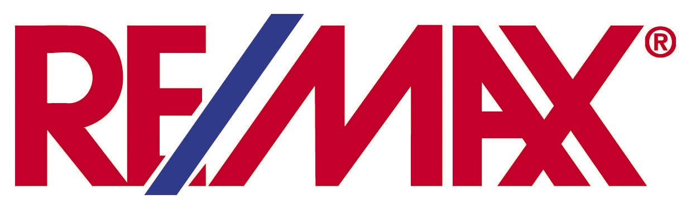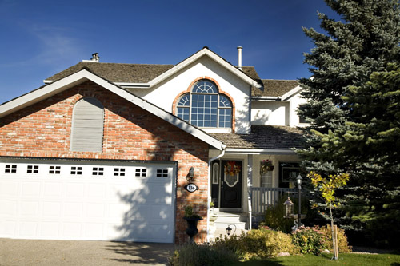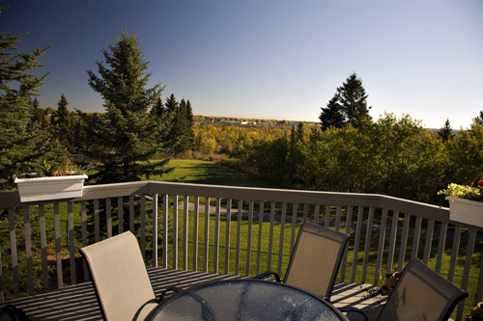**Financial Freedom Tip of the Month**

Office Address: 123 Any Street, Any Town, Any Province, 123456

*Here’s what others are saying…*

Wow! What a great experience purchasing our first home! You were knowledgeable, professional, and extremely attentive to all of our needs. As first time buyers, we had many questions and you were able to answer them all, as well as offer us valuable advice on the real estate market. You were highly organized and thorough in your research of properties, plus you were always available when we needed to meet with you. Thank you! **~John and Tammy Smith, Vancouver, BC**

**Shannon Lancy**

Realtor*®*

(413) 269-6958

shannonlancy.com

info@shannonlancy.com

**Awesome 4 Bedroom Home!** 4 Bedrooms, 2.5 Baths, 3 Car Garage**,** 2,325 sq. ft.**,** beautiful hardwood floors throughout**,** master suite with 3 piece master bath**,** professionally landscaped yard**,** large rear deck and patio**. Text code: “Buy124”**

**Your Dream Home Awaits!** 4 Bedrooms, 2.5 Baths, 3 Car Garage**,** 2,325 sq. ft.**,** beautiful hardwood floors throughout**,** master suite with 3 piece master bath**,** professionally landscaped yard**,** large rear deck and patio**. Text code: “Buy123”**

Text the code below to 79564 to receive more info – including **PRICE & FINANCING OPTIONS:**

**Stunning Lakeside Cabin!** 4 Bedrooms, 2.5 Baths, 3 Car Garage**,** 2,325 sq. ft.**,** beautiful hardwood floors throughout**,** master suite with 3 piece master bath**,** professionally landscaped yard**,** large rear deck and patio**. Text code: “Buy126”**

**Countryside Beauty!** 4 Bedrooms, 2.5 Baths, 3 Car Garage**,** 2,325 sq. ft.**,** beautiful hardwood floors throughout**,** master suite with 3 piece master bath**,** professionally landscaped yard**,** large rear deck and patio**. Text code: “Buy125”**

Saving for home renovations? Here’s how much the most common home renovation projects can cost you...



Renovations can help make your home more comfortable and easier to sell. But depending on what you’re planning, they can also be expensive—with prices even higher thanks to COVID. To help you budget for your next project, the HomeAdvisor website has published a list of typical costs for renovation projects.

Turns out the #1 most popular improvement project is interior painting. And it is popular because it makes a drastic visual impact for a relatively low cost—with home projects averaging $2,007 in 2020. High visual impact and affordability are also responsible for

making new flooring the #3 most popular project, with an average price of $4,680.

But while visual impact is always desirable, it doesn’t always come at a modest price. Bathroom remodeling ranks #2 on the popularity list, but its average price is $13,401. And kitchen remodeling ranks #5, but its average cost is a hefty $35,317! Rounding out the top six projects are #4 landscaping at $2,389 and #6 exterior painting at $3,291.

As we said, COVID had a significant impact on renovation project pricing in 2020. Compared to 2019, the price of additions was up 49%, closets up 38% and cabinetry up 30%. Time will tell if prices moderate or remain high once the pandemic recedes.

If you’d like to meet one of our trusted local renovator partners, call us today!

**Holistic Health Tip of the Month**

**Quiz Question of the Month**

* Before you go outside, check the pollen count on local weather forecasts. When counts are high, stay indoors as much as possible. Or go out later in the day when counts typically drop.
* When indoors, keep your windows closed and use a HEPA filter to remove tiny airborne particles like pollen.
* When driving, close your windows, shut the vents and recirculate the air in your vehicle.
* Vacuum frequently using a “pet-friendly” vacuum cleaner which is better at picking up pollen.
* Shower before going to bed. This removes all the pollen that your body and hair collect whenever you go outdoors.
* Wash your clothes after being outside to remove any pollen. And don’t dry your clothes on an outdoor line or rack where they can pick up more pollen.

Spring is a wonderful time of year, unless you suffer from spring allergies. Instead of enjoying the warmth and sunshine, allergy sufferers endure sneezing, coughing, congestion, runny nose, itchy eyes and worse. At the root of most of this suffering is pollen which is inhaled as fine, powdery particles in the air.

If your spring allergy symptoms are severe, consult your doctor. You may be prescribed antihistamines, decongestants, nasal steroid sprays or eye drops. But before you go the medication route, there are many steps you can take to reduce exposure to allergens:

How to enjoy spring with fewer allergy symptoms.

April Trivia Question

What is April’s birth flower?

1. Daisy or Sweet Pea
2. Snowdrop
3. Honeysuckle or Water Lily
4. Morning Glory or Marigold

**Answer to Last Month's Quiz**

Which of the following celebrities WASN’T born on St. Patrick’s Day, March 17?

1. Rob Lowe
2. Lady Gaga
3. Nat King Cole
4. Kurt Russell

ANSWER: b) Lady Gaga was born March 28, 1986

**How does this contest work?**

The first person to respond with the correct answer will win a FREE Dinner for themselves and another guest couple of their choice!

**How do I submit my answer?**

To respond with your answer, email us: email@yourweb.com or fax (xxx-xxxx) in your answer with the enclosed “Free Info” request form. The contest deadline is MM/YY.

**ANNOUNCING LAST MONTH’S WINNERS!**

Congratulations to Sarah and Dan Penner of North Vancouver for winning last month’s quiz contest! They have won a FREE dinner for themselves and another couple at the Salmon House in West Vancouver. Enjoy!

**Resource of the Month**

Make your reno finance itself AND raise the value of your home.

Sure, you’d love a freshly renovated home. But how are you going to pay for it? And is it really worth the expense? Get the answers to these and many other important questions in our latest FREE report called “9 secrets to making your home renovation pay for itself!”

**DELETE THIS AFTER READING!**

You can get access this guide here:

[tinyurl.com/mortgageguides](http://tinyurl.com/mortgageguides)

Inside, you’ll learn how affordable it is to access the existing equity in your home to pay for improvements. Also included are lots of expert renovation strategies to help ensure your return on investment is as high as possible. Yes, by choosing the right projects, you can spend LESS and end up increasing the resale value of your home MORE!

Here are just a few of the secrets included in this essential homeowner resource:

* Which renovations offer the highest return on investment.
* Which kitchen and bathroom upgrades buyers value the most.
* How to earn an even higher return on investment by enhancing energy efficiency.
* How to enhance your home’s marketability within the neighborhood.

If you thought renovations were too expensive or too self-indulgent, order this FREE report today. Our “9 Secrets” will convince you that renovations can enhance your lifestyle WHILE increasing your home’s value. Request your free copy by calling our 24-hour info hotlineat: 1-800-123-1234 Ext. 235.

As you can see, we’ve got a growing selection of free reports that are jam-packed with valuable tips and proven strategies to help you and your friends and family avoid costly financial pitfalls. If you’d like us to rush you one or more of these free reports, please fill out the reply form below and submit it by fax: 1-800-XXX-XXXX or snail mail it to: 123 any street, any town, any province, postal code.

Have you gained value from this newsletter? If so, we want to invite you to “pay it forward” by giving the **GIFT of a FREE SUBSCRIPTION** to your friends, co-workers, relatives, business acquaintances, etc. Simply fill out the info on the “Subscribe-a-Friend” form at the bottom of this page, and we’ll send them a free subscription. As a courtesy to you, we’ll also enclose a special note along with their first issue telling them that you asked us to surprise them with this free gift. And of course, they can contact us any time if they’d like to cancel. If you’ve been enjoying our newsletter, this is your hassle-free opportunity to share it with the people you care about - for FREE!

**“Do You Have All the Information You Need To Make An Informed Decision About Buying, Selling, or Refinancing Your Home?”**

###### YES! Please send the FREE Report(s) I’ve selected below: To Get Your Free Copy of Any Of These Reports Simply Call our 24hr Hotline 1-800-XXX-XXXX or Check Off The Ones You Want On This Form And Mail/Fax It In!

**Press Extension:**

[ ] “7 Steps to Stop Paying Rent and Own a Home Instead” - Ext. 1312

[ ] “8 Closing costs to be aware of before you get a mortgage” - Ext. 1313

[ ] “Ultimate Home Buyer Success Kit” - Ext. 1314

**YES!** **I’d like** **your trusted advice and counsel about:** _____ Getting a Mortgage _____ Refinancing _____ Other

**Your Contact Information:**

First Name ____________________________ Last Name _______________________________ Best time to contact _______________

Address _______________________________________________________________________________________________________

Town _____________________________________________ Province _________________ Postal Code _______________________

Phone _____________________________ Fax _______________________ Email________________________________________

**Don’t forget to send in your Client Quiz answer to win a FREE DINNER! Submit your answer by fax, mail or email.**

Also, please contact me to help me with: _____ Getting a Mortgage _____ Refinancing

**Don’t forget to send in your Client Quiz answers to win a FREE DINNER!**

**My answer for the Client Quiz of the Month is:** ________________________________________________

Also, please contact me to help me with: _____ Getting a Mortgage _____ Refinancing

**Don’t forget to send in your Client Quiz answers to win a FREE DINNER!**

**My answer for the Client Quiz of the Month is:** ________________________________________________

### “Free Info” Request Form

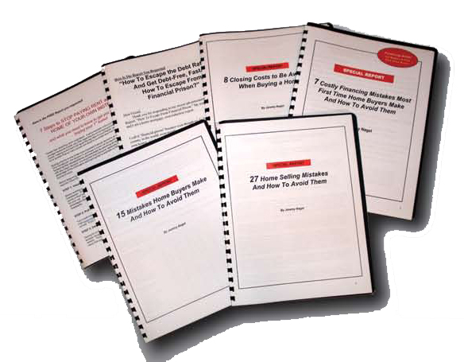

**Subscribe-A-Friend Request Form**

**[ ] YES! Please give the following people a FREE subscription to your monthly newsletter. I understand you’ll enclose a special note informing them that I asked you to surprise them with this free gift, and that all they have to do is contact you if they wish to cancel.**

Full Name _____________________________________________ Address ____________________________________________  
Town _______________________________________________ Province ___________________ Postal Code ________________

Fu Full Name _____________________________________________ Address ____________________________________________  
Town _______________________________________________ Province ___________________ Postal Code ________________

Please use the back of this form if you need more room. Remember to submit your Quiz answers to win a FREE dinner!



BEFORE YOU SEND OUT YOUR NEWSLETTER YOU MUST READ THESE IMPORTANT INSTRUCTIONS!

Dear Done4U Newsletter Member,

I want to make sure you understand how to get the most value from your Done4U client newsletter so you can build Top of Mind Consciousness with your prospects, clients and referral sources and maximize your referrals and repeat business.

Here are the critical steps you must take to ensure success with your newsletter:

**STEP #1:** Watch the orientation video to learn how to customize your newsletter. Just go to: <http://budurl.com/customizeletter> (personalize all text in red then turn it back to black).If this is not your FIRST issue, be sure to add in the answers to last month’s quiz and announce the winners.

Things to customize:

* Header
* Name of Newsletter
* Pic and Contact info (page 1)
* Client News
* Quiz of the Month: a) How to respond b) Last month’s winners
* Resource of the Month: Contact Info
* Free Info Request Form
* Cover Letter (If Applicable)
* Contest Insert (If Applicable)

**STEP #2:** If there are any articles included in this month’s issue that you don’t want to include, you can easily replace it with another article found in our article archive here: <https://b.link/articlearchive>

**STEP #3:** Get access to the customizable Done4U Lead Generation Reports at: <https://b.link/consumerguides>

**STEP #4:** If this is your inaugural issue, be sure to also enclose the following...

a) For your own newsletter [use this cover letter](https://drive.google.com/file/d/1yQDGiVE_1R9erCDH_EJQ9mMq9ybRmGNU/view?usp=sharing).

c) Consider adding the “Contest Insert” to explain the contest.

**STEP #5:** Send the customized file to your printer or send it to a fulfillment vendor to do it all for you. Find our recommended vendors at: [www.DorenRecommends.com](http://www.DorenRecommends.com).Be sure to get your newsletter in the mail by the 10th of each month or earlier.

**IMPORTANT:** be sure you follow these specifications…

* If you are printing full color, print double sided on white 11X17 paper
* If you are printing full black ink, print double sided on 11X17 colored paper (pastel green, canary yellow, or golden rod)
* Fold like a booklet
* If you choose to use a larger envelope than a basic No.10 envelope use the envelope document I provide and print the teaser copy on the front. You can also have it be a self-mailer (without an envelope), which makes it much more cost-effective to mail. Ask your fulfillment vendor for the difference in price between those two options.
* Use blue handwriting font for the return address and mailing address (no company name or logo)

Always use a separate colored color 8 ½ X11 sheet for the response form. If you use colored paper for the newsletter use white paper for response form.

**STEP #6:** Send a prize for your Quiz of the Month! The answer to this month’s quiz is…

ANSWER: A. Daisy or Sweet Pea