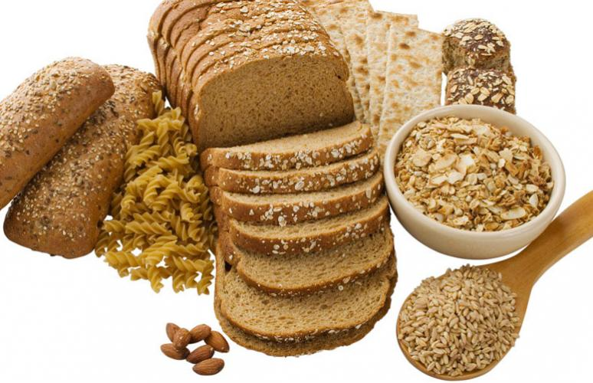

Whole grains are full of essential nutrients. But the way whole grains are consumed in industrialized countries limits available nutrients and inhibits digestion. Instead of preparing our whole grains the way civilizations have been doing for thousands of years, we fractionate them into bran, germ and starch; mill them at high temperatures; extrude them into flakes and O’s; and use other industrial processes to degrade their nutrients.

Whole grains contain many anti-nutrients which prevent the seed from sprouting until conditions are right. Necessary conditions include moisture, warmth, time and slight acidity. By providing whole grains with these conditions before consuming them, we can neutralize anti-nutrients that rob us of the grains’ goodness. One anti-nutrient is phytic acid which blocks the absorption of calcium, magnesium, copper, iron and zinc. Other anti-nutrients include enzyme inhibitors, tannins and complex sugars.

The good news is that all these anti-nutrients can be neutralized through proper preparation and consumption. Soak grains and lentils overnight before making porridge or casseroles, use sour dough fermentation to make bread, let some grains sprout before consuming. Adding animal fats like butter, lard and cream to your grains further increases absorption of calcium, phosphorous, iron and B vitamins.

To learn more about proper preparation and consumption of whole grains, consult your local health food store.

How to get optimal health out of the whole grains in your diet.