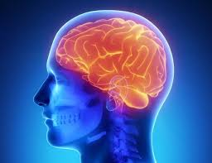

Ever wonder why sugary foods are so tasty and irresistible? It’s not because we have no willpower. What makes sugar so addictive is the way it reacts with our brains.

Whenever we do something pleasurable—like taste sugar—our brain produces dopamine which signals our prefrontal cortex to do it again and look for more ways to repeat that experience in the future. Repeated use of sugar over time causes spikes in dopamine release, prolonged dopamine signaling, greater excitation of the brain's reward pathways, and a higher tolerance for sugar.

Because it then takes more sugar to activate the dopamine receptors to the same level, we need to eat ever increasing amounts in order to experience the same “sugar high” we’re used to.  
  
The brain treats sugar as though it were an addictive drug, so it can be very difficult to wean ourselves off it. As we eat less sugar, we experience a dramatic loss of pleasure and comfort, and our brain chemicals constantly encourage us to reach out for more. Reducing sugar consumption is especially difficult because it’s in almost every processed food we eat, and those foods are advertised incessantly. But by gradually replacing processed sugar with less intensely sweet natural sources—like fruits and some vegetables—we can shake off our sugar addiction and live healthier, more balanced lives.

Turns out we don’t have a sweet tooth. We have a sweet brain!