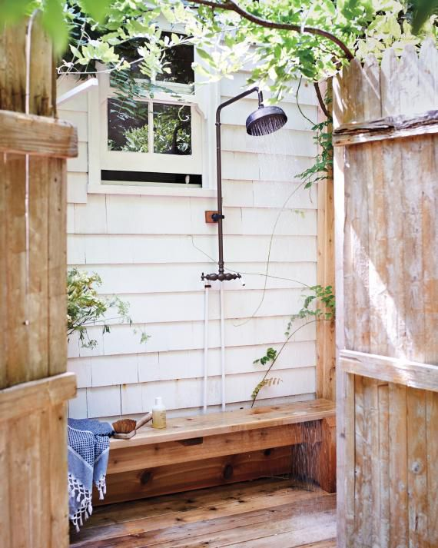

Make outdoor living even more fun with an outdoor shower.

You’ve got the yard, garden, patio and deck you always wanted. You use your fabulous outdoor space to cook and eat, grow food and flowers, play, laze and even occasionally sleep outside with the kids. Now make your experience complete with an outdoor shower.

First, think of all the practical reasons. Washing off all the dirt from gardening. Freshening up after vigorous play. Rinsing off the chlorine after a swim. Hosing the kids down after a meal of barbecued ribs!

Beyond that, there’s the luxury of warm sunlight on your skin as you stand under a stream of refreshing water. Or the quiet pleasure of looking up at the stars as you’re immersed in soothing warmth.

But remember, anything that’s worth doing is worth doing well. Don’t bother trying to cobble together a shower using a garden hose, since the water will be cold, it may not be safe for this purpose, and there won’t be adequate drainage. Instead, get a proper quote from a plumber for hot and cold water supply, fixtures, drainage and an attractive enclosure that still lets the sun and stars in.

If you and your family already spend much of the day—and night—in the yard, an outdoor shower will add extra practicality and enjoyment, not to mention the extra value it adds to your home!