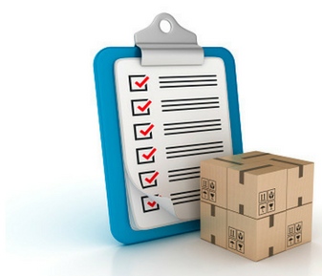

To request your free moving checklist, call us today at XXX-XXX-XXXX or email us at [abc@abcmortgage.com](mailto:abc@abcmortgage.com).

**Disclaimer:** Every move is different. While planning your move, decide how detailed you want your checklist to be and make the appropriate changes. We don't guarantee everything you'll need to consider is on this list.

**DELETE THIS AFTER READING!**

You can download this Moving Checklist from the members' site at: http://budurl.com/movechecklist

Of course, be sure to ask them if they have their finances arranged for the next home and get them preapproved for a mortgage.

Free moving checklist for a stress-free move!

Whether you're moving out of a home or an apartment, moving somewhere local or to another province, a Moving Checklist is an essential tool for planning and peace of mind. It's no small task packing your things, deciding whether to rent a truck or hire a mover, and keeping the whole process organized.

To help you in this, we have prepared a **free printable moving checklist** that takes you step-by-step – from what to do two months in advance (like arranging the transfer of medical records and scheduling utilities) to the weeks following your move (like completing your change of address checklist).