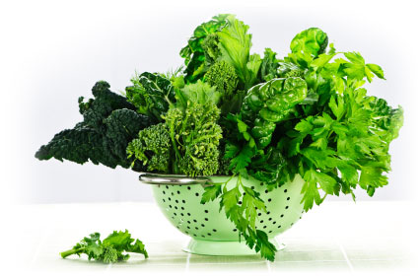

* Good source of vitamin K and calcium (except spinach and Swiss chard) which help prevent osteoporosis.
* High magnesium content and low glycemic index reduce the risk of diabetes.
* Lutein and zeaxanthin in dark-green leafy vegetables help protect eye health.
* Carotenoids, flavonoids and other antioxidants increase resistance to cancer.
* High in vitamin C, vitamin A and beta-carotene, which improve immune function.

Not only are leafy greens good for you, they add interesting flavors, colors and textures to your diet. Tastes range from sweet to bitter to peppery to earthy. They can be dark green, blue-green or bright green. And textures range from small, tender leaves to large, crunchy stems. Try a different leafy green every day of the week—either raw or cooked—and start enjoying better health!

Picture your last few dinners. Chances are, you may have had a lettuce salad. But what about all the other leafy greens out there? When’s the last time you ate Swiss chard, cabbage, beet greens, bok choy, kale, collard greens, broccoli, turnip greens or spinach? By adding more leafy greens to your diet, you gain important nutrients at a relatively low price.

Here are some of the health benefits of leafy greens:

* Ideal for weight management because they’re low in calories and fat, and high in dietary fibre. This also reduces the risk of cardiovascular disease.

Why leafy greens belong in your diet.