FREE Home Seller's Guide: How to avoid 27 costly home seller mistakes and sell your home *FAST* at Top Dollar... even in a buyer's market.

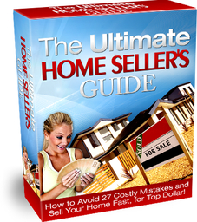

Since your home is one of your largest assets, selling it is probably one of the most important decisions you will make in your life. And once you've made that decision, you'll want to sell your home for the highest price in the shortest time possible, without compromising your sanity. To accomplish this, it’s important that you do your research so you don’t fall victim to costly mistakes.

With that in mind, I've prepared an informative resource titled, *The Ultimate Home Seller's Guide: How to Avoid 27 Costly Mistakes and Sell Your Home Fast at Top Dollar.*It reveals the "insider secrets" every home seller needs to know in order to make their home highly desirable, even in a buyer's market. (Actually, I don't know if these are secrets but I rarely see any home sellers follow this proven formula.) In this guide, you'll learn how to protect and capitalize on your most important investment, reduce stress, attract more qualified buyers and make the most profit in the shortest time possible. Don't even think about selling your home until you've read this important guide.  
  
To get your free copy of *The Ultimate Home Seller's Guide*, call our 24hr Info Hotline at 1-800-123-1234 Ext. 210. This offer valid while supplies last.