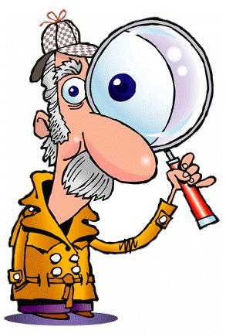

* Over-estimate the seriousness, urgency or expense of easy fixes.
* Criticize aesthetics, like colours, clutter, floor plan, etc.
* Predict life expectancy of components and appliances.
* Judge the “suitability” of a property for a family.
* Estimate the market value of the property compared to the asking price.

Here’s some of what home inspectors are ACTUALLY qualified to comment on:

* Current or future water/moisture/leak issues.
* Roof, flashing, chimney and skylight condition.
* Soundness of structure, including squareness of door frames and slopes of floors.
* Sealing of windows and doors, and adequacy of insulation.
* Operation of plumbing, electrical and heating/cooling systems.

To make sure you get someone who’s inspecting the correct things correctly, do a little research. Check to see if home inspectors in your area need to be certified and licensed. If so, make sure your inspector is a member in good standing of the professional association. Check the Better Business Bureau and online rating sites to uncover any known issues. Ask friends and neighbors which inspector they’d recommend. Get quotes and proposals from 2 or 3 inspectors and see who sounds the most thorough and professional.

If you’d like help choosing a home inspector, please give us a call. We can introduce you to one of our trusted local inspector partners who’d be happy to give you a no-obligation proposal.

A good home inspector can be a life-safer. By pointing out major flaws that might need to be fixed, your inspector can help you avoid making an expensive mistake or give you a legitimate reason to negotiate a lower price. But not all home inspectors provide a useful service. In fact, some inspectors miss important flaws or disrupt deals unnecessarily by exaggerating minor issues.

Failed home inspections are the #1 reason for home sales not to close. Most of the time, there’s a reasonable explanation for terminating the deal. But some home inspectors kill deals by incompetence, fraudulent intent or over-reaching their authority. For instance, they might:

It’s smart to do a pre-inspection of your home inspector.