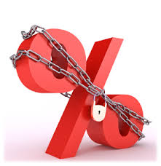

over time). The downside is that in order to provide you with that predictability, lenders usually charge higher interest on fixed-rate mortgages than on adjustable-rate mortgages. The higher rate covers the cost of keeping your rate steady even in a rising interest rate market.  
  
There are two main choices of terms for fixed-rate mortgages: 30-year and 15-year. The 30-year is more popular because its monthly payments are lower since they’re spread out over a longer time. This lets you buy a more expensive house. But it also means your total interest costs are higher. So even though you’re paying less per month, you end up paying more over time.  
  
Choosing between a 30-year or 15-year fixed-rate—or opting for an adjustable-rate mortgage—is complicated. You have to decide whether the security of predictable monthly payments is essential to your budget and ability to sleep at night. You have to consider how long you may live in the house and whether you may need to break out of the mortgage early. And you’ll want some insight into where mortgage rates are likely to be heading over the next several years.  
  
If you’re like most people, you’re going to need some help with all those decisions. As your local mortgage professionals, that’s what we specialize in. Please call us today for a free analysis of your situation and expert advice on choosing the best mortgage for you.

What you need to know about fixed-rate mortgages.

When choosing a mortgage, most Americans choose a fixed-rate. But just because fixed-rate mortgages are most popular, that doesn’t mean they’re necessarily a good fit for your specific financial situation, family needs, future plans or tolerance of risk.

The main attraction of fixed-rate mortgages is that the interest rate remains the same for the life of the loan, so your monthly payments don't change (unless they include property taxes, insurance premiums or condo association fees which can rise