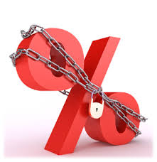

mortgages than on variable-rate mortgages. The higher rate covers the cost of keeping your rate steady even in a rising interest rate market.

Here are some things to keep in mind when considering a fixed-rate mortgage:

* Over the long-term—as interest rates rise and fall—the total interest paid with variable-rate mortgages is on average less than fixed-rate.
* A 1% rise in rates will cost you roughly $80 more interest per month for every $100,000 of mortgage.
* When the difference between a long-term fixed-rate and a variable-rate is less than 0.5%, you’re paying very little for the extra security of a fixed-rate.
* Many variable-rate mortgages let you lock in if rates start rising. However, some banks’ “conversion rate” can be 0.5% higher than their best discounted rates.

Choosing between a fixed-rate or variable-rate is complicated. You have to decide whether the security of predictable monthly payments is essential to your budget and ability to sleep at night. You have to consider how long you may live in the house and whether you may need to break out of the mortgage early. And you’ll want some insight into where mortgage rates are heading over the next several years.

If you’re like most people, you’re going to need some help with all those decisions. As your local mortgage professionals, that’s what we specialize in. Please call us today for expert advice on choosing the best mortgage for you.

What you need to know about fixed-rate mortgages.

When choosing a mortgage, most Canadians choose a 5-year fixed-rate. But just because fixed-rate mortgages are most popular, that doesn’t mean they’re necessarily a good fit for your specific financial situation, family needs, future plans or tolerance of risk.

The main attraction of fixed-rate mortgages is that the interest rate remains the same, so your monthly payments don't change. The downside is that in order to provide you with that predictability, lenders usually charge higher interest on fixed-rate