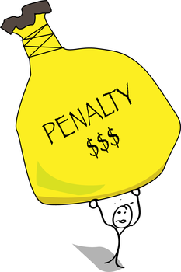

rate you actually received. This can add as much as 1%—or more—to the IRD calculation. And on top of that, if you break out of your mortgage to go to a new lender, you usually also have to pay about $1,000 in legal fees.  
  
With all these complications and potential expenses, it’s tough to decide whether it makes sense to break out of your mortgage early. If you’d like some help evaluating your IRD costs, talk to us today. We’d be happy to do a free analysis of your specific situation and help you make the most cost-effective decision.

If you’re thinking about breaking out of your mortgage early to get a better rate or to access equity, make sure you know how much you’ll be paying in IRD (interest rate differential).  
  
An IRD is a prepayment penalty charged by the bank to cover the future income it loses when you break out of your mortgage early. The way banks calculate IRD is complicated. Basically, they take the difference between the rate you locked in at and the lower rate they’re currently charging, then multiply that by your balance and the number of years remaining. To make the IRD even more expensive, banks use their posted rate at the time you took out the mortgage, rather than the discounted

IRD: what you need to know before breaking out of your mortgage.