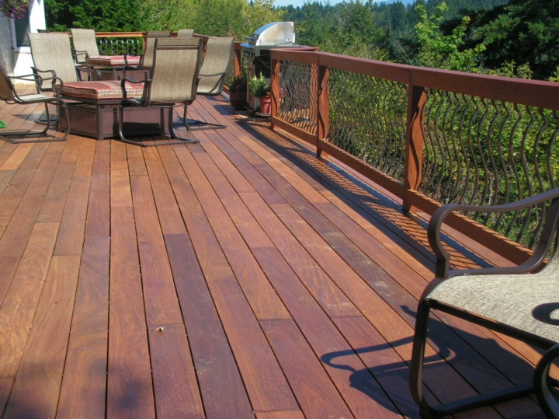

1. **If your railing’s failing.** Sometimes wood railings are the first part of your deck to decay. This can be a safety hazard, as well as reducing visual appeal. Consider upgrading your railing to metal, cabling or glass. The price is higher, but maintenance costs will be less, and your deck will seem even more like an extension of your interior space.
2. **Grow what you eat.** Eating on the deck is even more fun if the greens, herbs and tomatoes were grown right on site. Place containers in sunny spots that are easily accessible to the kitchen. Use saucers to keep water from pooling on the deck. And make sure you don’t exceed your deck’s weight capacity.

4 ways to add livability to your wood deck.

In summer, your deck may be the most used “room” in the house. Here are some practical ways to add extra utility and enjoyment.

1. **Ongoing maintenance.** While wood is beautiful, it needs help to retain that beauty. Refinish your deck every couple of years with quality stains and sealants. Eliminate areas or objects that allow moisture to collect. Remove furniture and debris for winter.
2. **Add privacy and beauty.** If you feel exposed on your deck—or if you’d like some shade from the sun—consider planting shrubs and small trees along the perimeter. If you can’t plant directly into the ground, use containers—but remember they’ll need regular watering.