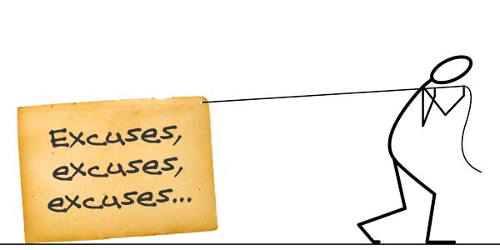

1. I’ll worry about the future when it gets here.
2. Sure, we can afford it, I have overdraft protection.
3. I'll start saving next year when I'm earning more.
4. If everybody stopped borrowing and spending, the economy would tank.
5. At my age, it's too late to start saving.
6. Driving my kids around in an older car would be unsafe
7. For the sake of my marriage, I let him/her buy whatever he/she wants.
8. I work hard. I deserve this (something expensive).
9. I want my kids to have everything I did without.
10. We need a new RV so we can spend more family time together.
11. I'll pay off that credit card balance when I get my tax refund.
12. I’ll start a budget next month.
13. An expensive new car is an investment.
14. Why save? It only gets eaten up by inflation and taxes.
15. The bank wouldn’t have approved me if I couldn’t afford it.
16. It’s OK, I’m expecting a big inheritance.

If you’d like to take control of your finances, that’s a great excuse to call us for free advice and support!

Nobody wants to stay deep in debt and poor forever. So what’s preventing us from adopting better money habits? Our mistaken beliefs! It’s easier to believe change is impossible rather than actually trying to make change happen. Here are some common excuses that prevent us from becoming financially secure:

16 excuses that can keep you poor.